Shadows in GIMP (it’s more of a black glow but uhh ok)

You should have your image into gimp now with correct colours:

So, what you want to do is right click on the layer the image is in, and press Alpha to Selection.

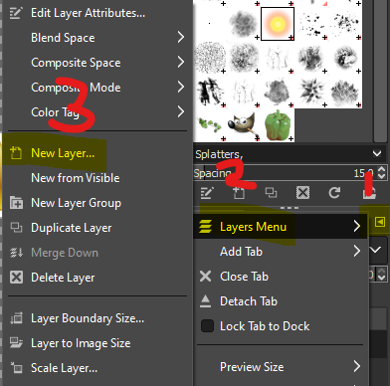Grow your selection (using Select -> Grow) by 2px.

Now, create a new layer called Glow, make sure the background is set to be transparent.

Use the Bucket Tool with the colour black selected.

Drag your glow layer below the image one.

Deselect everything.

Finally, apply a gaussian blur. Use the TELOP ROUND preset.

Final Result:

